St Josephs Primary School
Design and Technology Long term Overview

 | AUTUMN | SPRING | SUMMER | Famous Artist
Key stage 1 Cycle A | GREAT FIRE OF LONDON  Using Art as historical evidence  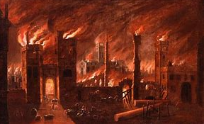 | PORTRAITS  Using Art as historical evidence  Drawing and painting skills  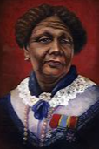  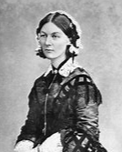  LANDSCAPES  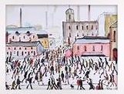  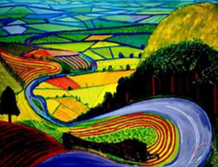  Drawing and Painting | PRINTING  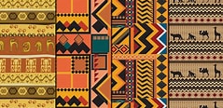  Exploring African tribal patterns  SCULPTURE  Moulding African animals using clay material  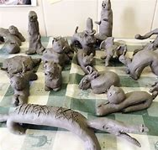 | Philippe-Jacques de Loutherbourg
Key Stage 1, Cycle B | DRAWING & SKETCHING  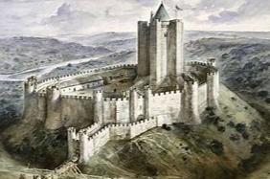  Using shading | HOT & COLD  Exploring colour wheels  Children mix colours and tones  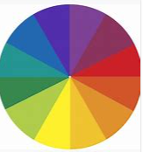 | SCULPTURES  Investigate famous sculptural landmarks artists found in the UK  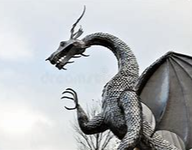  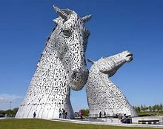  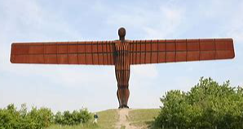 | Kandinsky

Year 1 and lower key stage 2 | WATE RCOLOUR  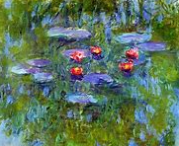  Impressionism | PENCIL TECHNIQUE/SKETCHING  Adding shadows to Roman artefacts  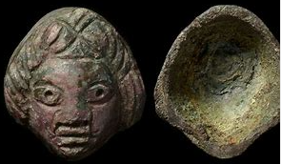 | POP ART  Use of vivid colours and outline  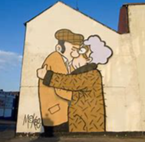 | Claude Monet  Pete McKee
Year 1 and lower key stage 2, Cycle B | CLAY WORK- MOULDABLE MATERIALS  Creating Tiles  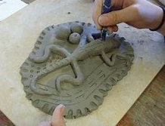  DRAWING WITH PASTELS  Creating the northern lights with pastels  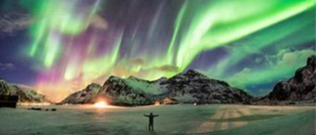 | PORTRAITS  Portraits in the style of Frida Kahlo  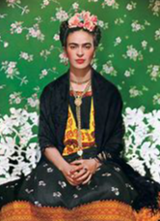  SURREALISM  Dali and Miro  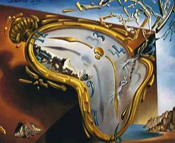 | CUBISM  Pablo Picasso -The Egyptian  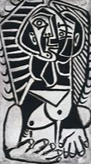  POP ART Romero Britto  Use of Colour for effect  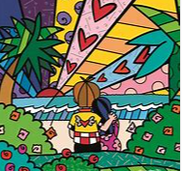 | Romero Britto  Pablo Picasso
Upper key stage 2, Cycle A | CLAY WORK  Terracotta stone wear linked to ancient Greece  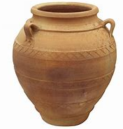 | SCULPTING  Henry Moore and Barbara Hepworth  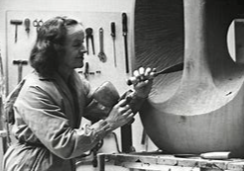  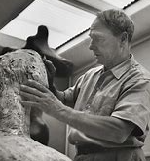 | DIGITAL ART  David Hockney (joiners)  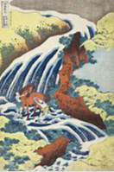  DRAWING & PRINTMAKING  Katsushika Hokusai
Upper key stage 2, Cycle B | DRAWING  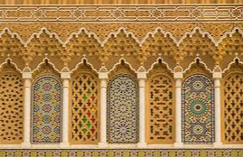  Sketching skills, eg tone and hatching using Islamic art, patterns and motifs  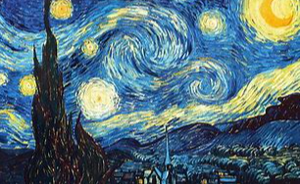  Vincent Van Gogh- Starry Night | PERSPECTIVE  CLAUDE LORRAIN – BAROQUE ART  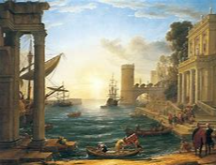 | COLOUR & PENCIL TECHNIQUE  George O’Keefe Flowers  