St Joseph’s Catholic Primary School
Long term plan for Geography
 | Year One and Two
Spring 1 | Topic: The World Around Us  Focusing on our local area, children learn about the area they live in and where this fits within the world. Children draw various maps of their area.  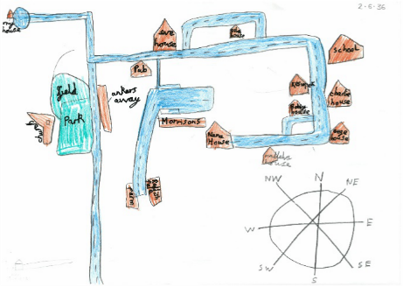
Summer 1 | 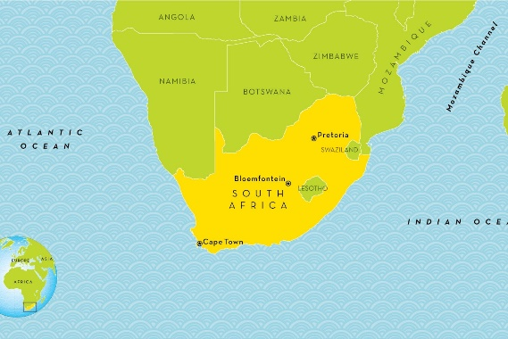  Topic: Let’s go on Safari  Learn about seven continents and five oceans with a focus on South Africa, exploring the country’s human and physical features focusing on the features of a coastal region, comparing this to Rawmarsh.

 | Year Three and Four
Autumn 2 | Topic: A Drop of Water  Big Question: Do rivers shape our lives?  Children learn about the water cycle, the features of a river and how we use rivers in our lives.  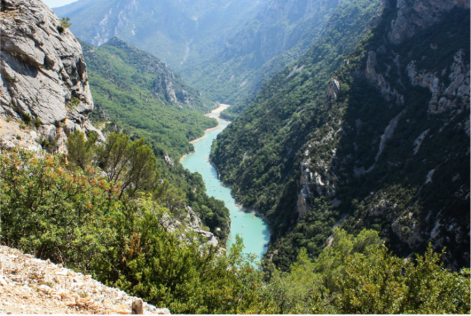
Summer 2 | 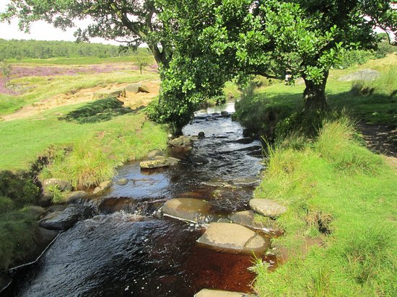  Topic: Our Local Area- Fieldwork in Sheffield  Big Question:  Children will conduct fieldwork in the local area, recording data, and presenting findings of the human and physical Geography within the area.

 | Year Five and Six
Autumn 2 | 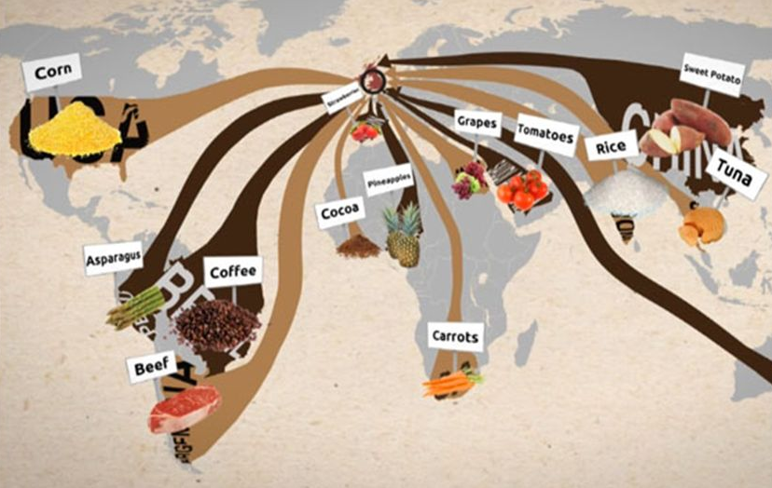  Topic: Food Trade  Big Question: Where does our food come from?  Children explore where different food products come from, what the UK imports and exports and why, as well as the socio and economic impacts of air miles. Children also explore Fairtrade and the importance of buying locally.
Summer 2 | 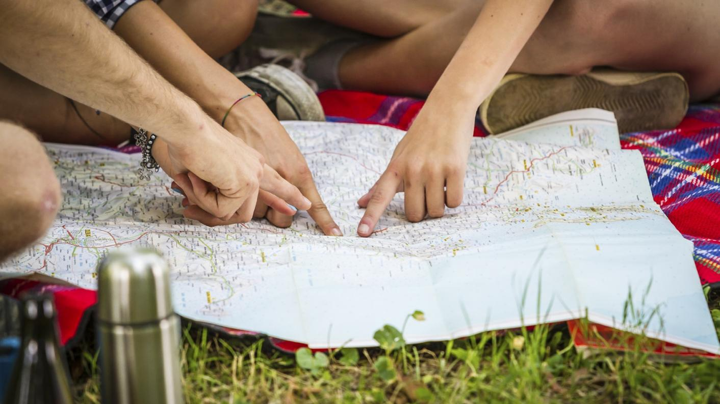  Topic: Fieldwork in Derbyshire  Big Question:  Children will conduct fieldwork in the local area, recording data, and presenting findings of the human and physical Geography within the area.

