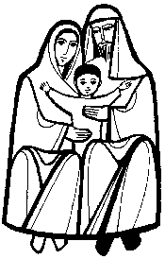
St Joseph’s Catholic Primary School
Long term plan for History

 | Year One and Two
Autumn 1 | Topic: Castles  The events of the Norman conquest and the building of Conisbrough Castle, its development, design and purpose  The lives of Elizabeth I and Elizabeth II  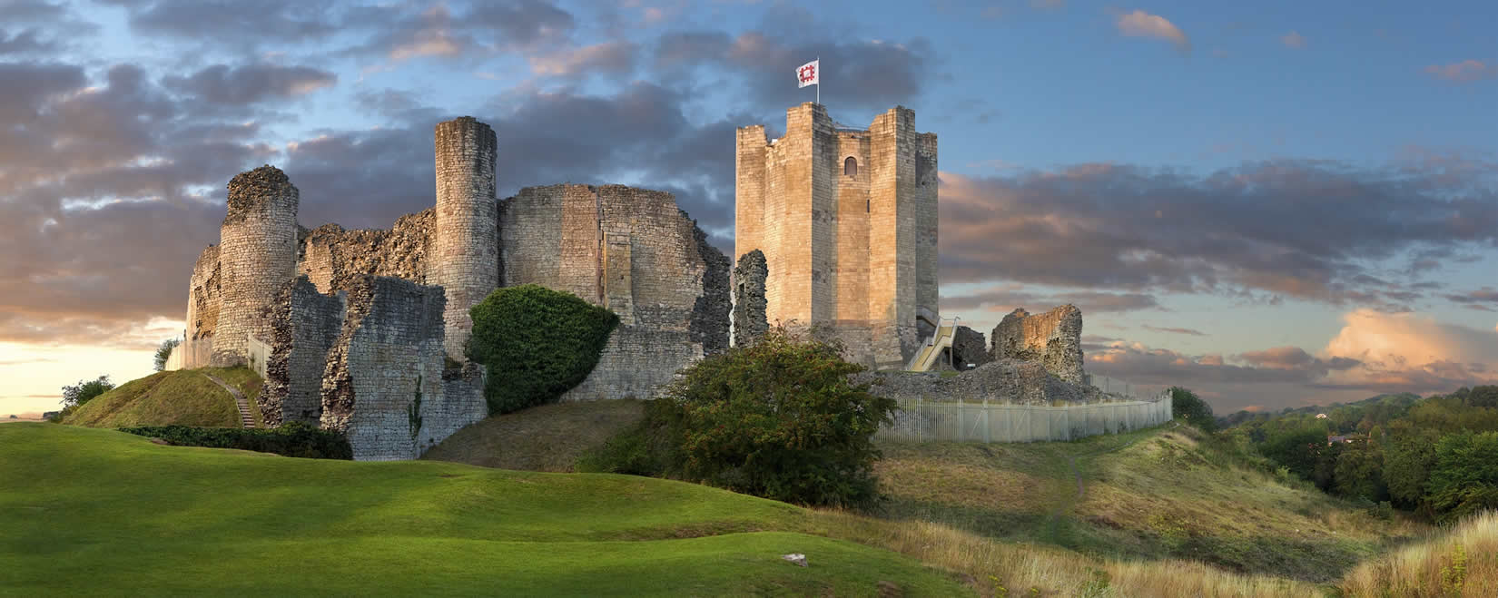
Spring 2 | Topic: Victorian childhood  The experiences of rich and poor children in Victorian times.  